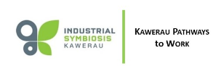

Workplace training helps locals obtain jobs

The Kawerau Pathways to Work programme helped Shaun Spanhake obtain a full-time job.
Check out the interview of Shaun by reporter Nathan Morton for the New Zealand Herald online.

https://www.nzherald.co.nz/nz/news/article.cfm?c_id=1&objectid=12330548

The programme was initiated by the ISK (Industrial Symbiosis Kawerau) group which is supported by the Kawerau District Council, Iwi and industry and aims to develop people for the jobs and opportunities that will be delivered by the Kawerau Putauaki Industrial Development (KPID).

Earlier this year, the Kawerau Putauaki Industrial Development received a total of $19.2m Provincial Growth Funding. Kawerau Pathways to Work received Provincial Growth Funding in 2019.

Unfortunately, the impact of the COVID-19 pandemic on businesses and industry has put a hold on the Kawerau Pathways to Work programme. As the programme relies on cadets being placed into business and many of these are experiencing tough times, it is currently being reviewed.

